USE COLLEGE;

**SLICE:** Filtering data based on a specific department (AI&DS)

SELECT fe.enrollment_id, st.student_name, c.course_name, i.instructor_name, s.semester_name, fe.grade

FROM fact_enrollments fe

JOIN students st ON fe.student_id = st.student_id

JOIN courses c ON fe.course_id = c.course_id

JOIN instructors i ON fe.instructor_id = i.instructor_id

JOIN semesters s ON fe.semester_id = s.semester_id

JOIN departments d ON st.department_id = d.department_id

WHERE d.department_name = 'AI&DS';

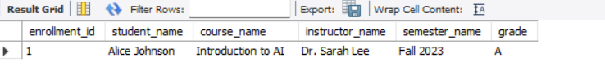

**DICE:** Filtering data for a specific course and grade (Introduction to AI, Grade A)

SELECT fe.enrollment_id, st.student_name, c.course_name, fe.grade, fe.enrollment_date

FROM fact_enrollments fe

JOIN students st ON fe.student_id = st.student_id

JOIN courses c ON fe.course_id = c.course_id

WHERE c.course_name = 'Introduction to AI' AND fe.grade = 'A';

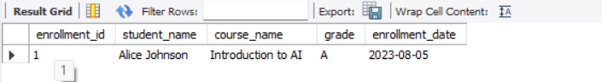

**ROLLUP:** Aggregating data by department and semester

SELECT d.department_name, s.semester_name,

COUNT(fe.enrollment_id) AS total_enrollments

FROM fact_enrollments fe

JOIN students st ON fe.student_id = st.student_id

JOIN departments d ON st.department_id = d.department_id

JOIN semesters s ON fe.semester_id = s.semester_id

GROUP BY d.department_name, s.semester_name

WITH ROLLUP;

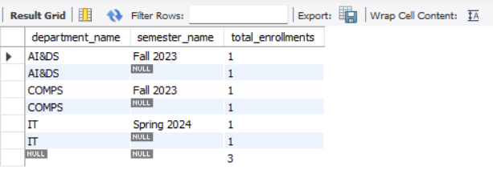

**DRILLDOWN:** Viewing detailed enrollment data for a specific semester (Fall 2023)

SELECT fe.enrollment_id, st.student_name, c.course_name, i.instructor_name, s.semester_name, fe.grade

FROM fact_enrollments fe

JOIN students st ON fe.student_id = st.student_id

JOIN courses c ON fe.course_id = c.course_id

JOIN instructors i ON fe.instructor_id = i.instructor_id

JOIN semesters s ON fe.semester_id = s.semester_id

WHERE s.semester_name = 'Fall 2023';

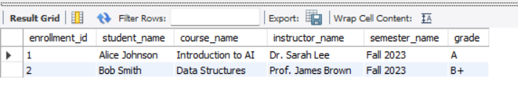

**PIVOT:** Simulating a pivot table by converting rows into columns for grades

SELECT d.department_name,

SUM(CASE WHEN fe.grade = 'A' THEN 1 ELSE 0 END) AS grade_A,

SUM(CASE WHEN fe.grade = 'B+' THEN 1 ELSE 0 END) AS grade_B_plus,

SUM(CASE WHEN fe.grade = 'A-' THEN 1 ELSE 0 END) AS grade_A_minus

FROM fact_enrollments fe

JOIN students st ON fe.student_id = st.student_id

JOIN departments d ON st.department_id = d.department_id

GROUP BY d.department_name;

